**International University**

School of Computer Science and Engineering



**Course: Object-Oriented Programming**

**Final Report**

**Class Instructor: Dr. Tran Thanh Tung - tttung@hcmiu.edu.vn**

**Lab Instructor: Msc. Nguyen Quang Phu - tttung@hcmiu.edu.vn**

**Course: Object-Oriented Programming**

**Game Name: ESCIGMA**

**Members:**

1. Hoàng Thiên Ân - ITSIU22248 - anhoang935
2. Nguyễn Phát Lợi - ITCSIU22081 - zzhahazz
3. Thái Quang Tính - ITCSIU22222 - notrealqt
4. Nguyễn Huỳnh Minh Đức - ITCSIU22218 - minhduckd5
5. Nguyễn Trọng Thuận - ITCSIU22223 - Tynaz196

**CHAPTER 1: PROJECT DESCRIPTION 4**

1.1.INTRODUCTION 4

1.2 LITERATURE REVIEW 4

1.3 METHODOLOGY 4

1.4 APPROACH 5

1.5 RESULT 7

**CHAPTER 2: PROJECT TIMELINE 11**

**CHAPTER 3: PROJECT ANALYSIS 13**

3.1 UML 13

3.2 OBJECT DESIGN 14

Character: 14

Monster: 16

Boss 16

Items: 17

Map 18

3.3 CLASS AND FUNCTION 19

Entity: 19

Items: 30

Main: 38

Managers: 41

Map: 54

Mics: 56

Res: 62

3.4 STORY AND GAMEPLAY 62

1. The meaning of “Ecsigma” 62

2. About the Story 63

3. The gameplay 64

1.Commencement: 64

CHAPTER 4: FUTURE PLANS 65

REFERENCES 66

# CHAPTER 1: PROJECT DESCRIPTION

## 1.1. INTRODUCTION

The project at hand employs object-oriented programming (OOP) as its cornerstone to develop a game. This endeavor relies on the four fundamental properties of OOP and various programming methods to create a comprehensive gaming experience.

## 1.2. LITERATURE REVIEW

The "Escigma" project is a venture into crafting a 2D game within the Visual Studio Code platform, utilizing the Java programming language. This game aims to blend accessible gameplay with an engaging narrative. Numerous classes, such as Player, NPC, and Monster, are integral to the game's architecture. Emphasis is placed on designing a user-friendly interface to enhance the overall gaming experience.

## 1.3. METHODOLOGY

* UML (Unified Modeling Language): A visual language in software engineering to conceptualize and communicate system designs. It aids in exploring potential designs and validating architectural choices.
* ArrayList: Part of the java.util package, a resizable array offering adaptability for efficient data management with dynamic addition or removal of components.
* Loop: A control flow statement enabling the iterative execution of a code block based on a specified Boolean condition.
* Try-Catch: A structure where code susceptible to exceptions resides in the try block, while the catch block handles exceptions, preventing abrupt application termination.
* Draw Function: Primarily used for rendering or redrawing graphical elements, such as shapes, text, and images on a component.
* If-Else: A conditional statement determining code execution based on a specified condition, enhancing decision-making in the program.
* Runnable Interface: An interface designated as "runnable" must be implemented by a class intended to be run by a thread.
* Node: A fundamental data structure used in various non-sequential data structures like linked lists and trees, consisting of data and connections to other nodes.
* Library: Utilized for code modularization, libraries offer reusable functions or classes, reducing the amount of code that developers need to create.

## 1.4. APPROACH

To synthesize our efforts, we have identified seven key folders crucial for the creation of a 2D game, forming an interconnected and cohesive whole:  
 1. Misc: This component plays a pivotal role in aiding NPCs, monsters, and bosses in finding the optimal path to the player through the utilization of Nodes. It also oversees the player's progress, encompassing data storage, progression tracking, and save/load functionality. The classes associated with this entity are as follows: DataStorage, Progress, SaveLoad, Node, and PathFinder.

2. Entity: As the core component of the game, this entity is crucial for creating and managing various entities within the game environment. It takes charge of initializing character statistics and manages parameters, functions, and images for both bosses and monsters. The classes affiliated with this entity include Dummy, Entity, NPC_Injured, Player, Projectile, BOSS_HumanCollector, and MON_GreenSlime,...

3. Main: Functioning as the central hub for game creation and execution, this entity pre-arranges items, parameters, and events. It holds the responsibility of drawing the game application. The classes associated with the Main entity are GamePanel and Main.

4. Managers: Dedicated to preparing different stages of the game, Managers configure game settings, encompassing object positions, character placements, and monster settings. They adeptly handle in-game events, integrate shortcuts, and manage images and sounds. The classes affiliated with this entity include AssetSetter, CollisionDetector, Config, VutSceneManager, EventHandler, EventRect, KeyHandle, Sound, UI, and UtilityTool.

5. Item: This entity is tasked with managing in-game items, handling the creation of functions and images for various items. The classes associated with Item are Axe, Boots, Chest, Door, Fire_Sword, Heart, Key, ManaCrystal, MasterKey, Shield, Sword, and WormHole.

6. Res: An indispensable entity for displaying the game, Res stores images, sounds, and text fonts. Image files are saved in PNG format, while sound files are preserved in WAV format.

7. Map: Utilized for creating game maps by translating images into game data, the Map entity determines how the data impacts the main map of the game. The classes affiliated with this entity are Map, Tile, and TileManager.

## 1.5 RESULT

a. Game Run Success:

* The game executes successfully, encompassing all essential functions for an adventure game.
* The development journey reveals numerous bugs, emphasizing the necessity of rigorous testing to identify and rectify issues.

b. Challenges: The development of this game brought forth a series of challenges, including the creation of functional items, the implementation of reliable monster and boss mechanics, the orchestration of cutscenes, and the crafting of a compelling ending. However, each of these challenges served as a crucible of valuable learning experiences. Throughout the process, we honed our skills in creating intricate functions and adeptly utilized libraries to transform these challenges into attainable milestones.

c. Comparison with Initial Goal:

At the project's inception, our vision aimed for gameplay centered around maze exploration, with movement guided by lines drawn through mathematical equations. Additionally, we envisioned creating multiple maps with escalating difficulty levels. However, upon delving into the coding process, we encountered formidable challenges, realizing that additional knowledge was necessary to align the game with our original vision. To ensure timely completion and alleviate project pressures, we made a strategic decision to shift the character's movement mechanism to the more conventional WASD keys. Despite this adjustment, key aspects from our initial vision, such as the implementation of buff and debuff items and the integration of teleportation points, were successfully retained. These elements not only increased the game's complexity but also added an intriguing layer to the overall experience.

In the evolution of our project, we expanded the scope by introducing four distinct maps, enhancing the game's variety. The initial maze exploration concept took an exciting turn, incorporating dynamic action elements, allowing players to engage in thrilling monster battles. While the inclusion of monsters and bosses was not initially part of our plan, we recognized the need for heightened competition, leading to their strategic incorporation to captivate and challenge players.

In essence, the project's journey involved a nuanced adaptation of our initial vision, showcasing the team's flexibility and creativity in response to challenges and the evolving nature of game development.

## 1.6 DISCUSSION:

The journey through the development of "Escigma" has been a captivating exploration into the practical implementation of Object-Oriented Programming (OOP) principles within the intricate landscape of game development. It stands as a compelling example, highlighting the inherent prowess and adaptability that OOP brings to the forefront of this creative process.

The deliberate embrace of OOP has fundamentally shaped the game's development, introducing a methodical and efficient approach. The modular structure, synonymous with OOP, not only enhances code readability but also lays the foundation for a scalable and maintainable project. This design philosophy not only eases the current development stages but also positions the game for the seamless integration of future features.

The significance of OOP is prominently displayed in the coherent organization of various game elements. NPCs, monsters, bosses, items, and maps find their place within well-defined classes, fostering a clean and organized codebase. This compartmentalization ensures a straightforward debugging process and provides the flexibility necessary for ongoing updates and feature expansions without compromising the game's stability.

Beyond the technical facets, the adaptability ingrained in OOP played a pivotal role throughout the iterative development phases. As the project evolved, the team could readily adjust and refine existing features, effectively addressing challenges and enhancing gameplay mechanics. This adaptability not only accelerates the development cycle but also fortifies the overall resilience and longevity of the game.

In summary, the successful implementation of Object-Oriented Programming in "Escigma" transcends the mere simplification of development; it elevates the game to a level of sophistication and robustness. Beyond the lines of code, it underscores the significance of structured methodologies in game development, illustrating how the thoughtful application of programming paradigms contributes to the creation of engaging and dynamic gaming experiences.

### 1.6.1. Further Discussion on SOLID Principles:

1. Single Responsibility Principle (SRP): The SRP manifests in "Escigma" by ensuring each class has a singular responsibility, promoting code organization and maintainability. The CollisionDetector class, for instance, solely handles collision-related operations, aligning with the SRP and contributing to the project's overall coherence.

2. Open/Closed Principle (OCP): OCP finds expression through the use of interfaces and abstract classes in "Escigma." This allows for the addition of new features without modifying existing code, fostering extensibility. Classes like AssetSetter and Config exemplify OCP by being open to extensions, facilitating seamless updates and enhancements.

3. Liskov Substitution Principle (LSP): "Escigma" adheres to LSP by ensuring that subclasses, such as various types of monsters or NPCs, can replace their parent classes without causing unexpected behaviors. This adherence fosters flexibility and consistency in the codebase, contributing to a more robust and adaptable game.

4. Interface Segregation Principle (ISP): ISP is evident in "Escigma" through tailored interfaces to specific needs. For instance, the UI class deals exclusively with user interface elements, preventing classes implementing it from being burdened with unnecessary methods. ISP contributes to a more cohesive and modular design.

5. Dependency Inversion Principle (DIP): DIP is implemented through dependency injection and the use of interfaces in "Escigma." Higher-level classes, like GamePanel or Main, depend on abstractions, allowing for flexibility in changing implementations without affecting the overall structure of the game. This principle enhances the project's adaptability and maintainability.

## 1.7 CONCLUSION:

In summation, the incorporation of Object-Oriented Programming (OOP) has significantly enhanced the systematic and efficient progression of this game's development. Beyond the immediate benefits of improved code readability and maintenance, the application of OOP principles positions the project for a more straightforward integration of new features in the future. The systematic approach fostered by OOP not only streamlines the current development process but lays a foundation for the continued evolution and expansion of the game, ensuring its adaptability and longevity.

# 

# CHAPTER 2: PROJECT TIMELINE

| Start - End Date | Description of Workforce Allocation and Task Execution |
| --- | --- |
| Tu 14/11/2023 | * Task: Assembling Essential Resources * Objective: Establish the foundational resources required for project initiation. |
| Thursday 16/11/2023 | * Task: Identifying Tasks and Role Allocation * Objective: Define specific tasks and allocate roles strategically for a synchronized team effort. |
| Tu 21/11/2023 | * Task: Offline Strategic Discussion * Objective: Deliberate on the strategic approach to the project and establish a comprehensive framework. |
| Thursday 26/11/2023 | * Task: Gathering Ideas from Team Members * Objective: Solicit creative inputs and ideas from team members to enrich the project's conceptual foundation. |
| Tu 28/11/2023 | * Task: Sorting and Choosing Implementation Ideas * Objective: Evaluate and refine gathered ideas to decide on the definitive path of implementation. |
| Sun 10/12/2023 - Sun 7/1/2024 | * Task: Code Implementation * Objective: Engage in the coding process, bringing the envisioned project, "Escigma," to life. |
| Mon 8/1/2024 - Thursday 18/1/2024 | * Task: Software Testing, Bug Identification/Fixing, and Final Touches * Objective: Rigorously test the developed code, identify and rectify bugs, and add final touches for a polished result. |
| Fri 19/1/2024 | * Task: Formal Presentation * Objective: Present the finalized project, "Escigma," to peers and stakeholders, culminating the project timeline. |

# CHAPTER 3: PROJECT ANALYSIS

## 3.1. UML

Package entities: <https://raw.githubusercontent.com/notrealqt/oop-project-IU/main/Report/UML/entities/entities.png> 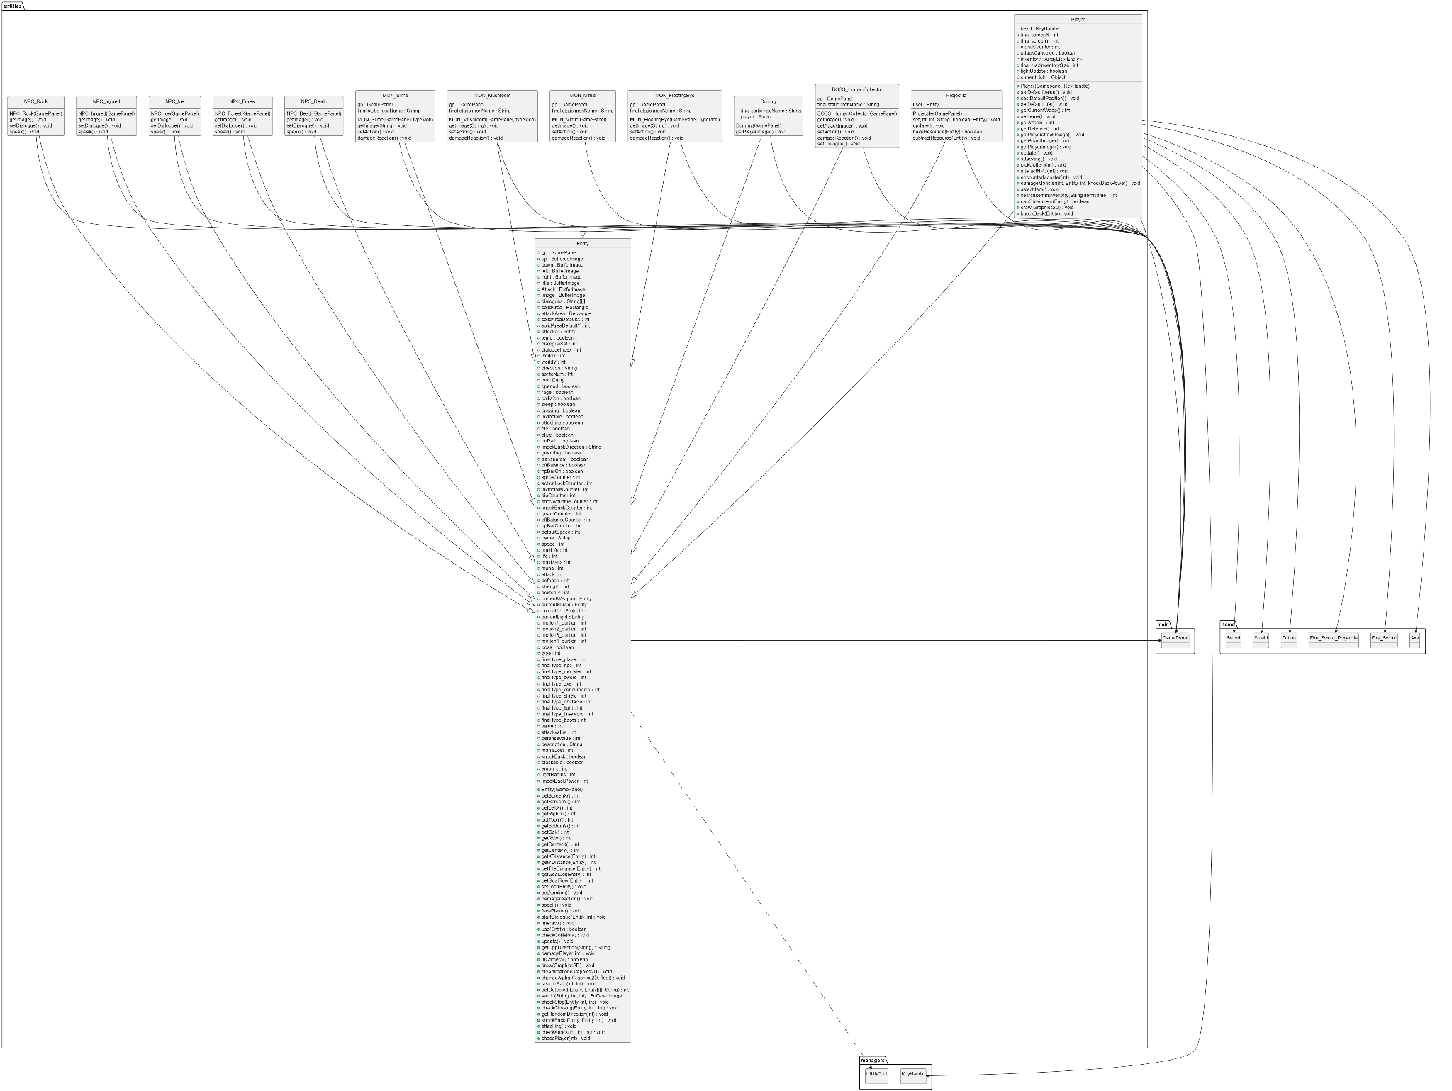

Package items: <https://raw.githubusercontent.com/notrealqt/oop-project-IU/main/Report/UML/items/items.png> 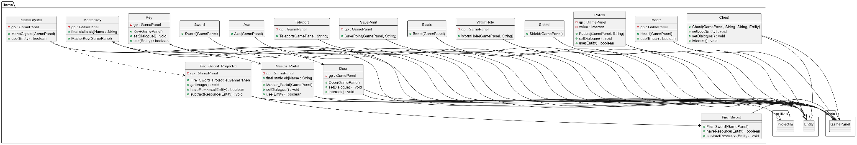

Package main: <https://raw.githubusercontent.com/notrealqt/oop-project-IU/main/Report/UML/main/main.png> 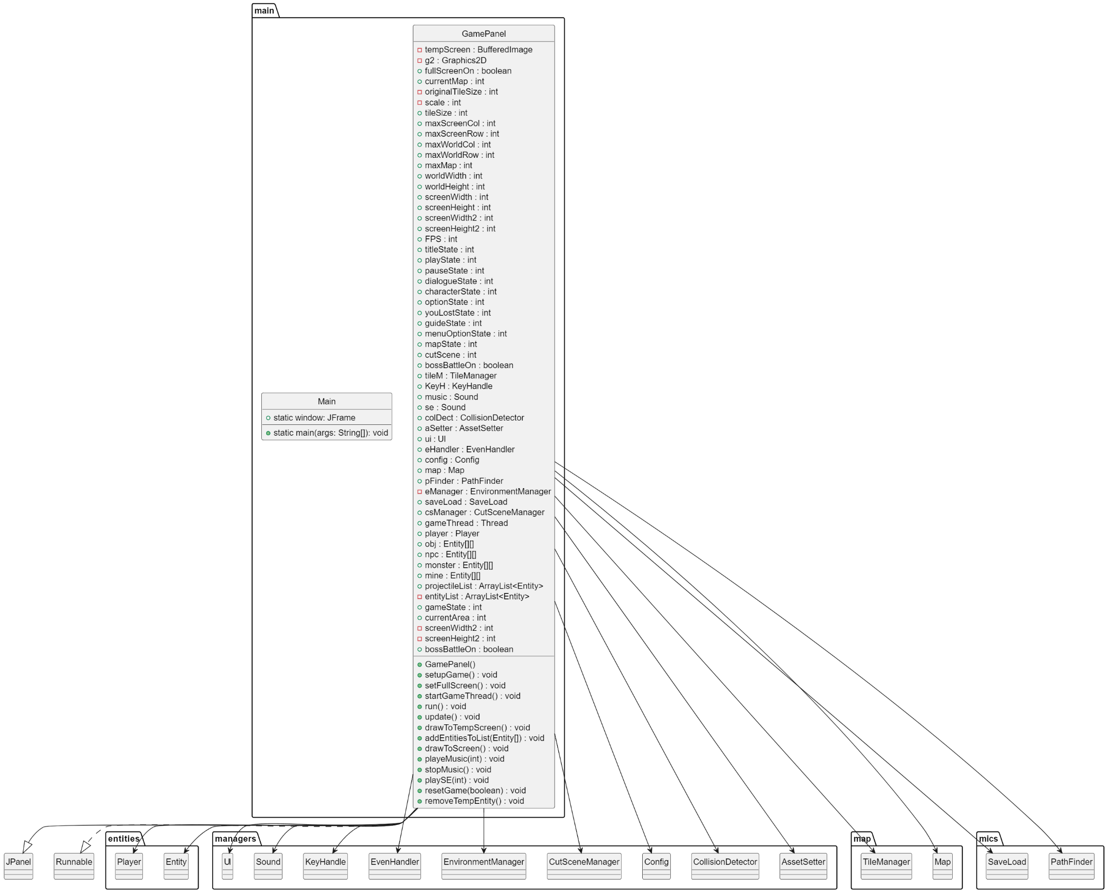

Package managers: <https://raw.githubusercontent.com/notrealqt/oop-project-IU/main/Report/UML/managers/managers.png> 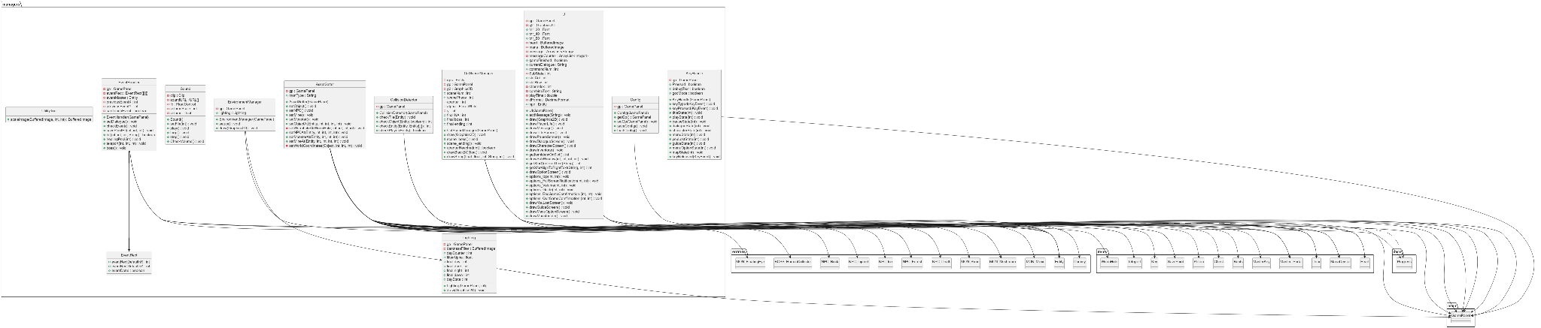

Package map: <https://raw.githubusercontent.com/notrealqt/oop-project-IU/main/Report/UML/map/map.png> 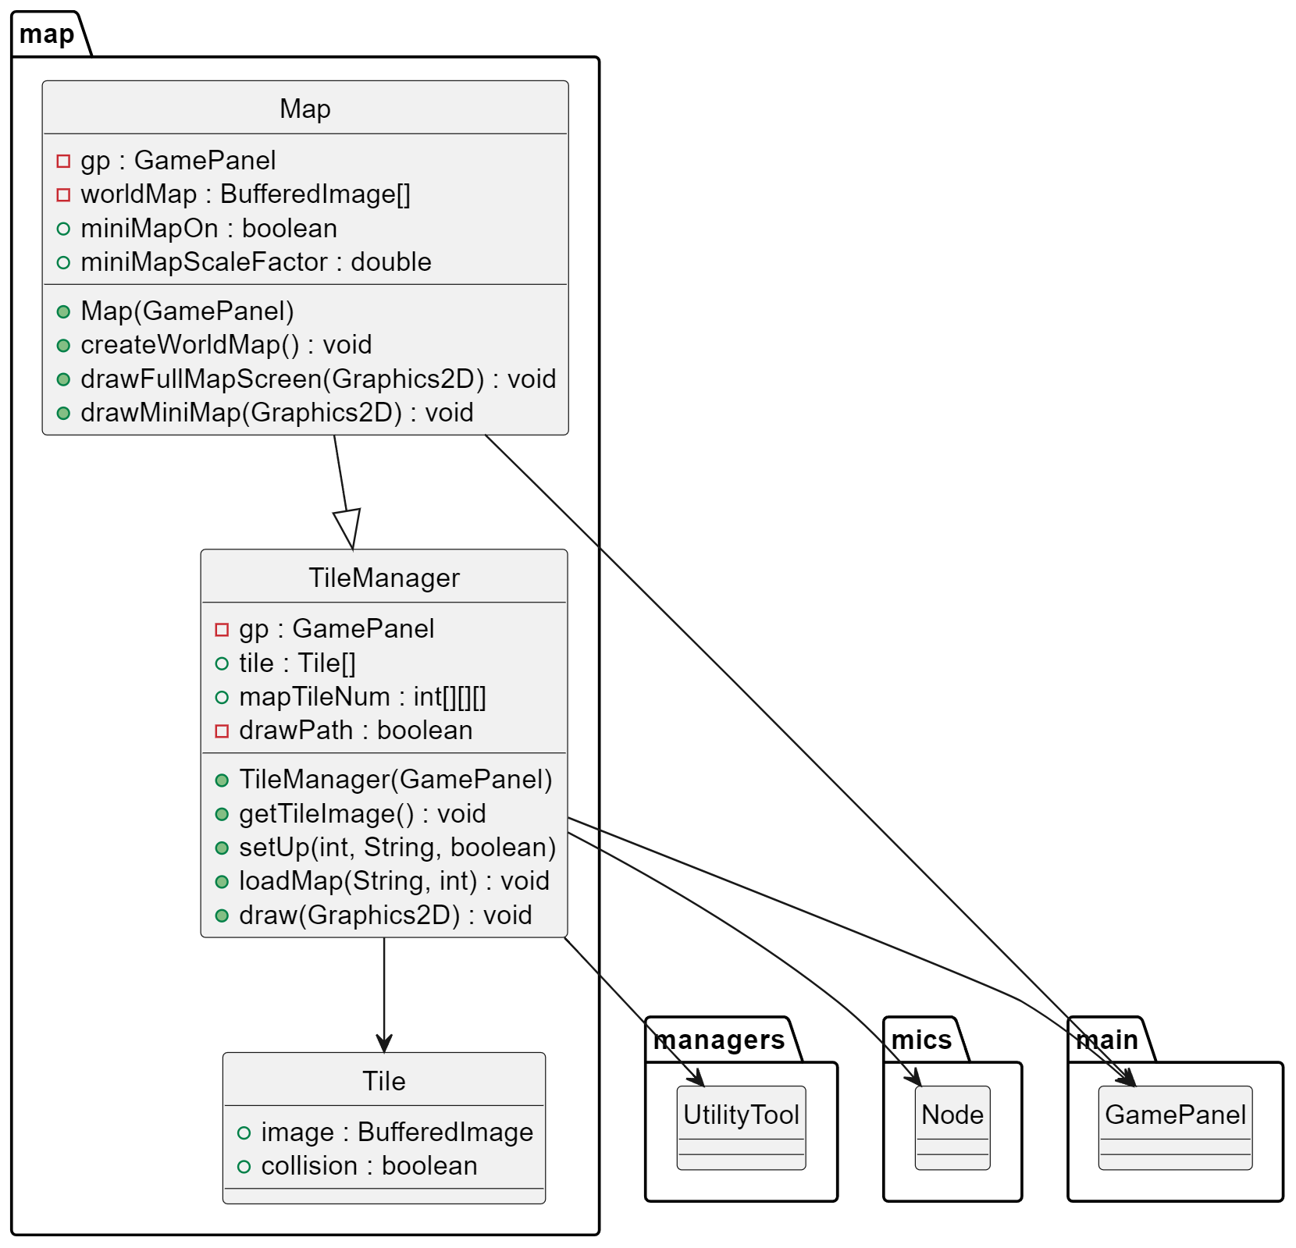

Package mics: <https://raw.githubusercontent.com/notrealqt/oop-project-IU/main/Report/UML/mics/mics.png> 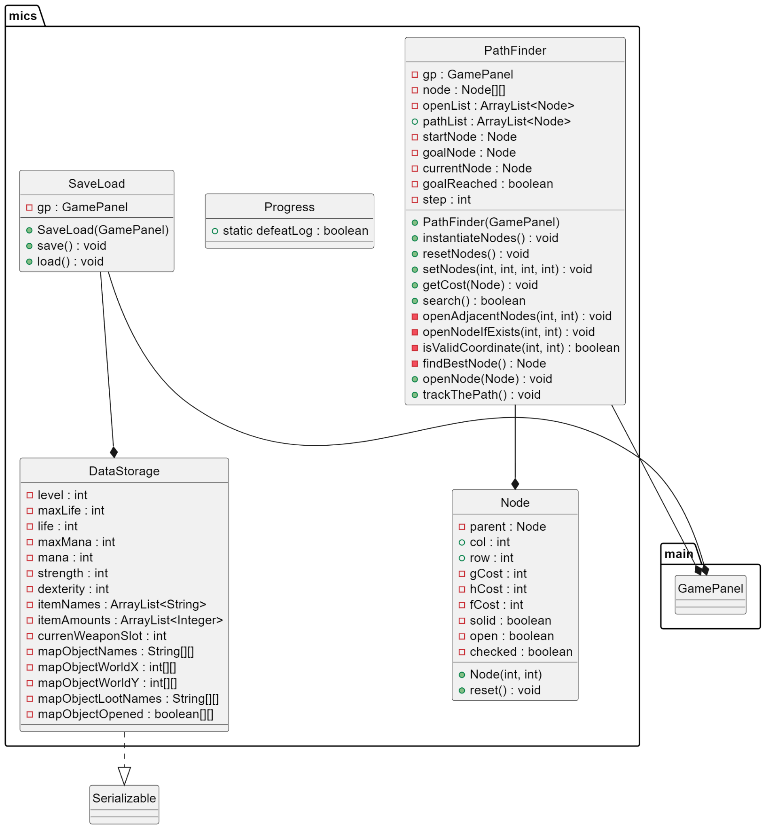

## 3.2. OBJECT DESIGN

### Character:

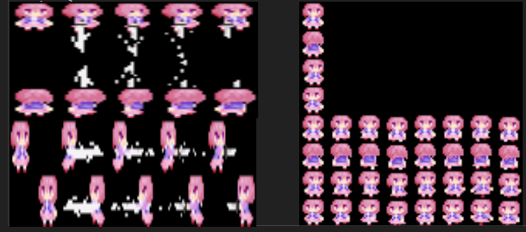

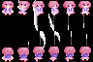



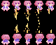



### Monster:

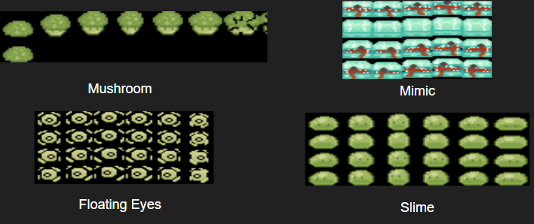



### Boss:





### Items:







### Map:

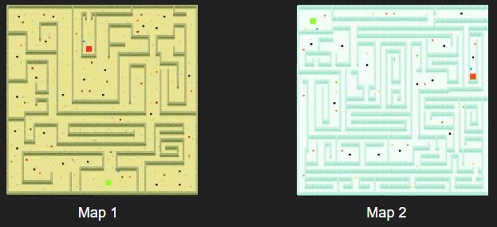

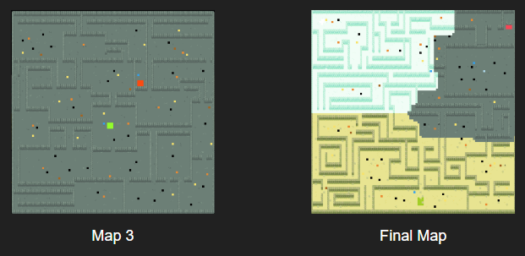

## 3.3. CLASS AND FUNCTION

### Entity:

Class Boss:

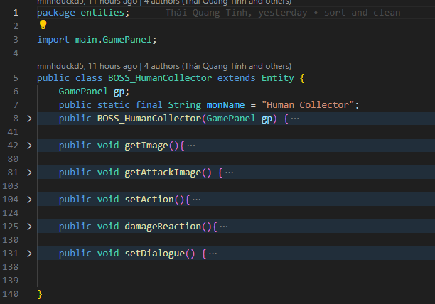

Class Dummy:

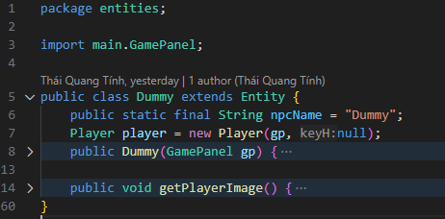

Class Entity:

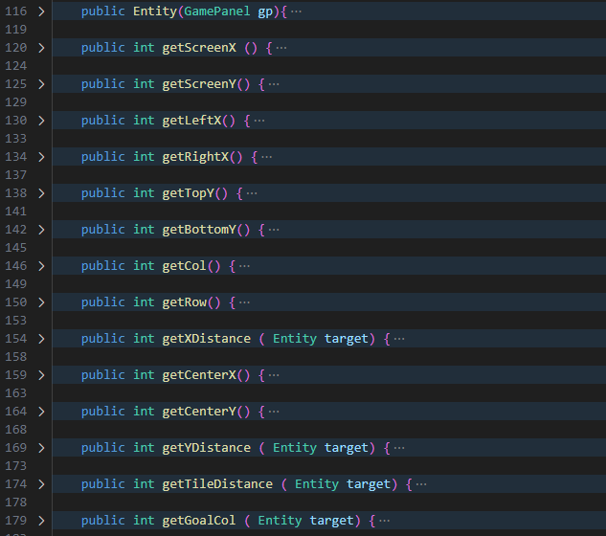

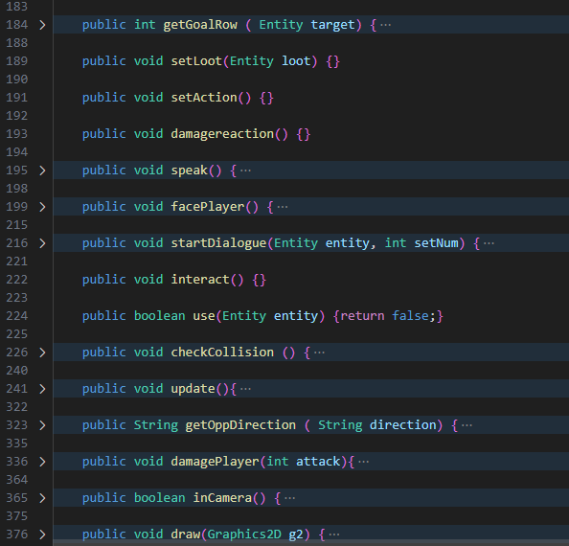

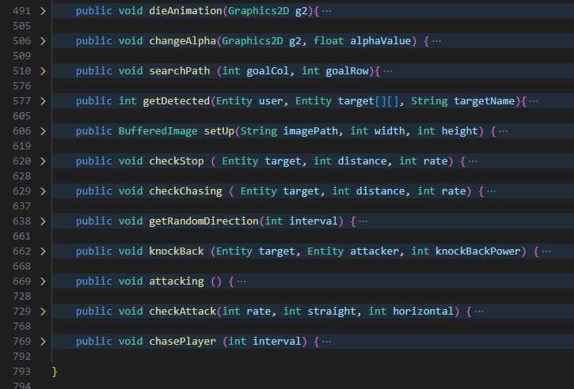

Class MON_FloatingEye:

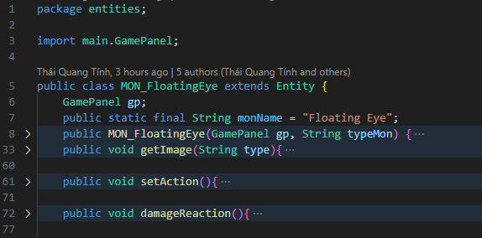

Class MON_Mimic:

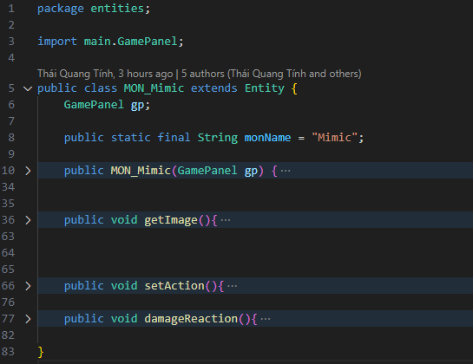

Class MON_Mushroom:

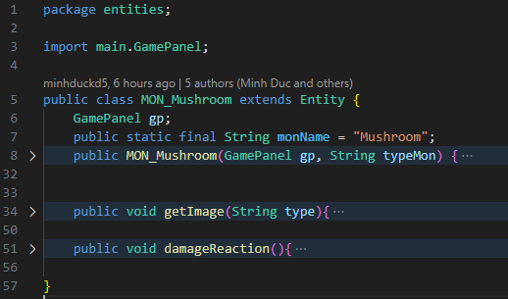

Class MON_Slime:

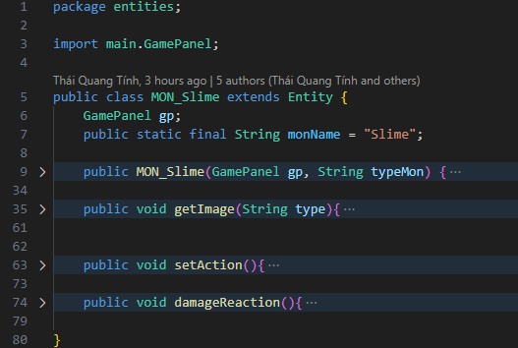

Class NPC_Death:

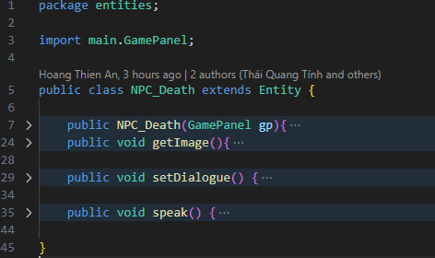

Class NPC_Forest:

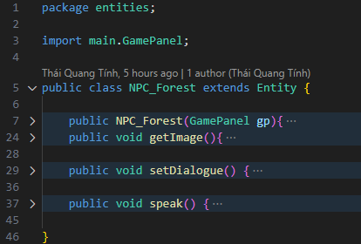

Class NPC_Ice:

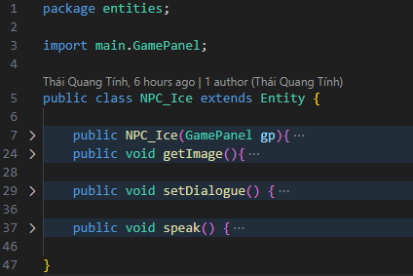

Class NPC_Injured:

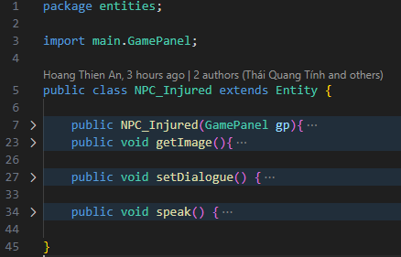

Class NPC_Rock:

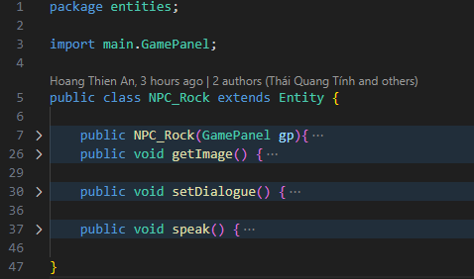

Class Player:

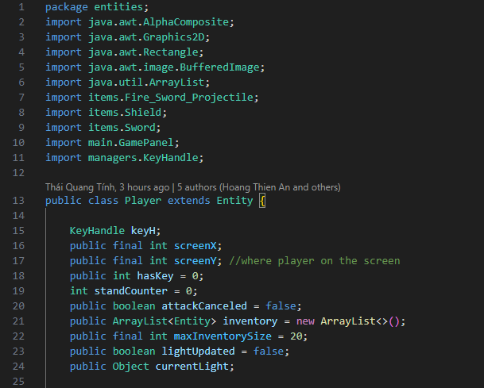

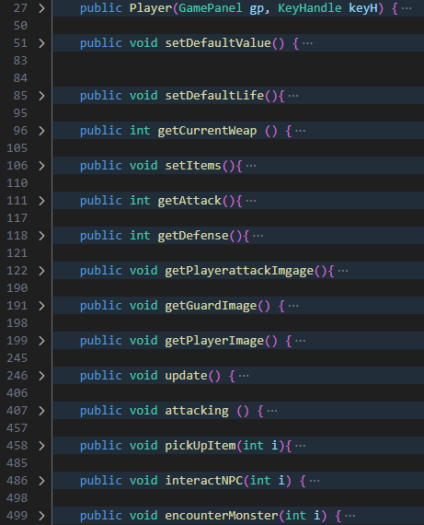

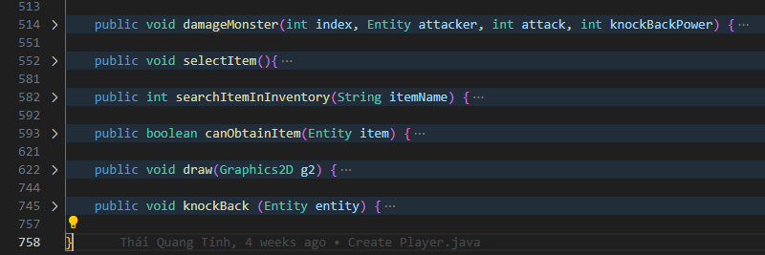

Class Projectile:

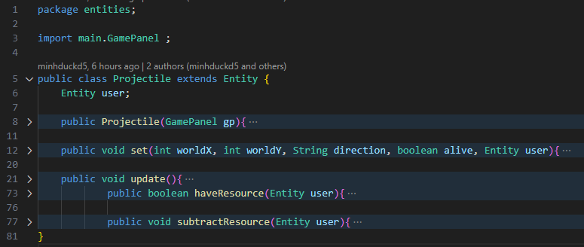

### Items:

Class Axe:

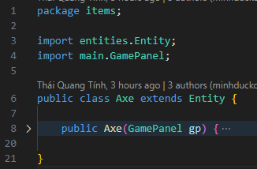

Class Boots:

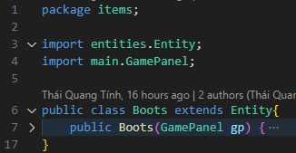

Class Chest:

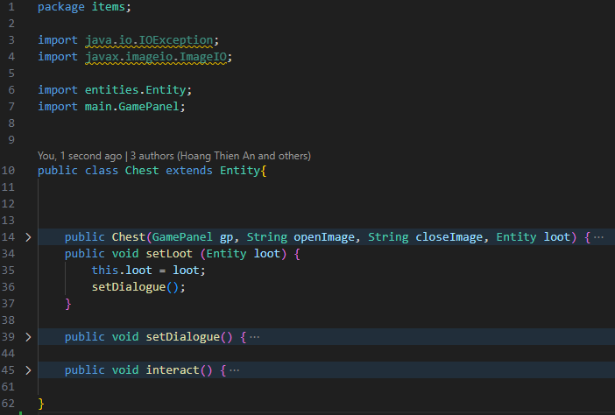

Class Door:

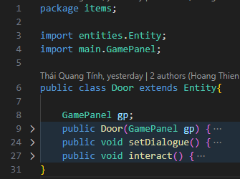

Class Fire Sword Projectile:

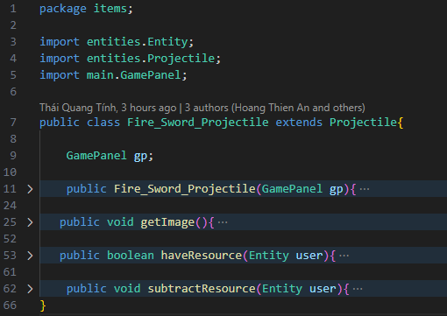

Class Fire Sword:

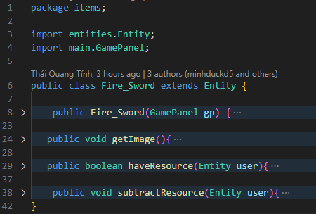

Class Heart:

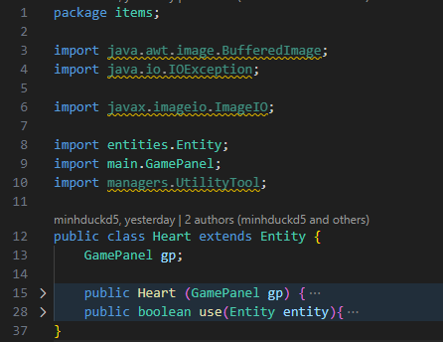

Class Key:

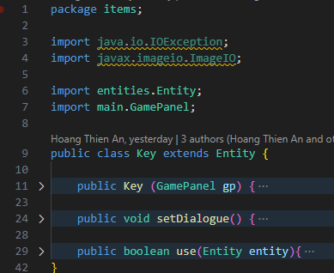

Class Mana Crystal:

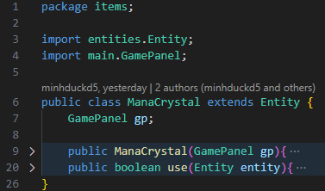

Class Master Key:

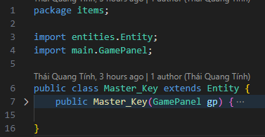

Class Portal:

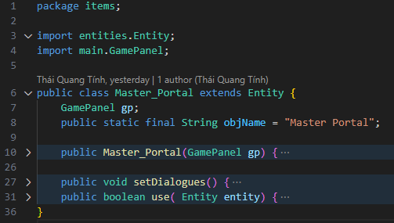

Class Potion Dexterity:

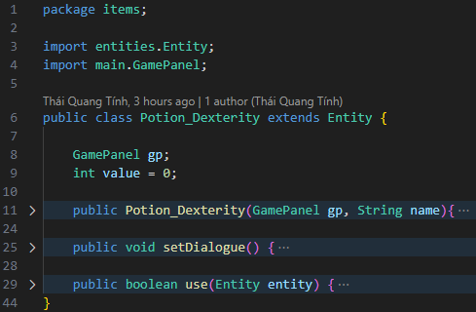

Class Potion Health:

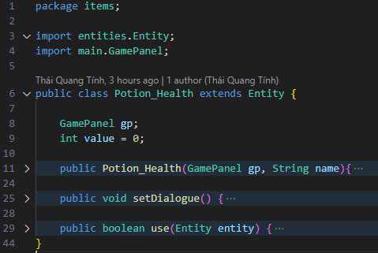

Class PotionMana:

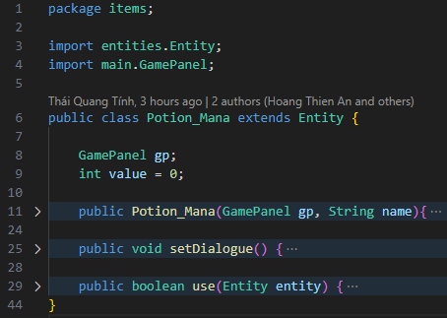

Class Potion Strength:

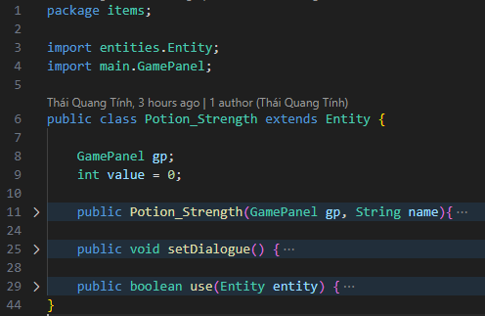

Class Save Point:

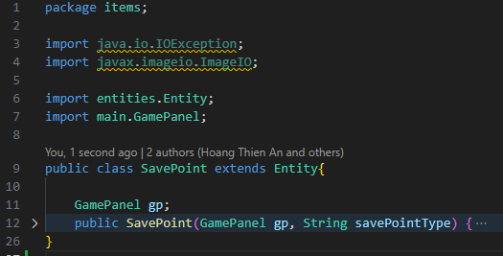

Class Shield:

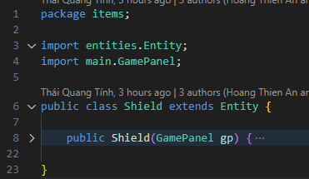

Class Sword:

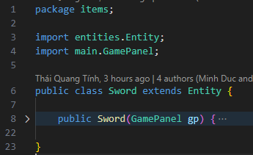

Class Teleport:

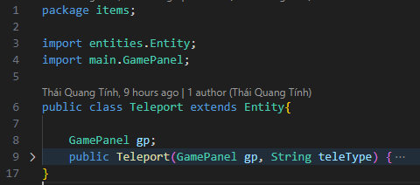

Class Worm Hole:

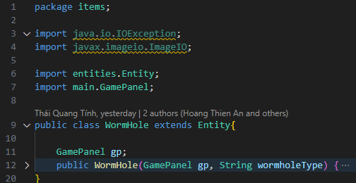

Class Game Panel:

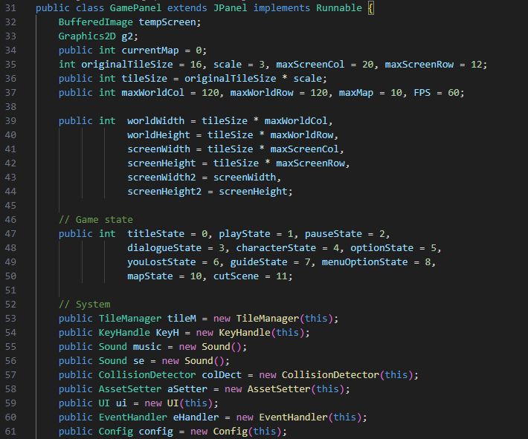

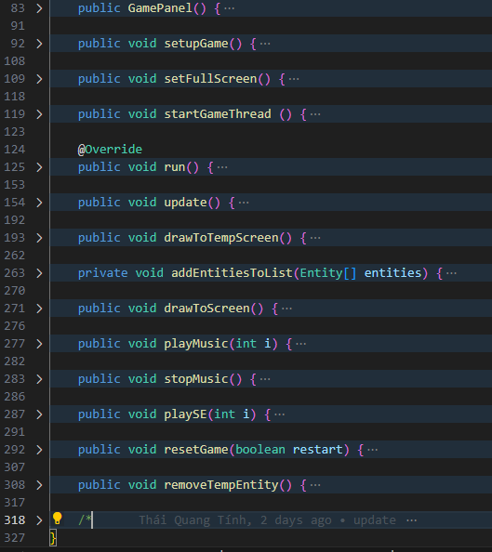

Class Main:

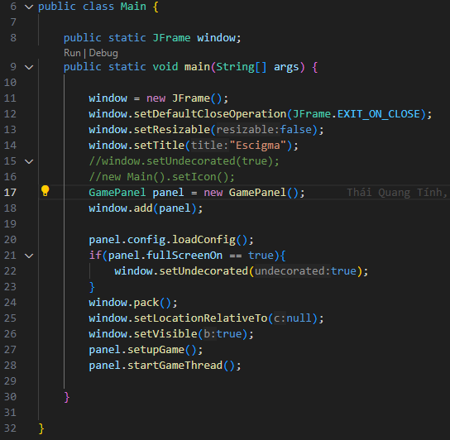

### Managers:

Class Asset Setter:

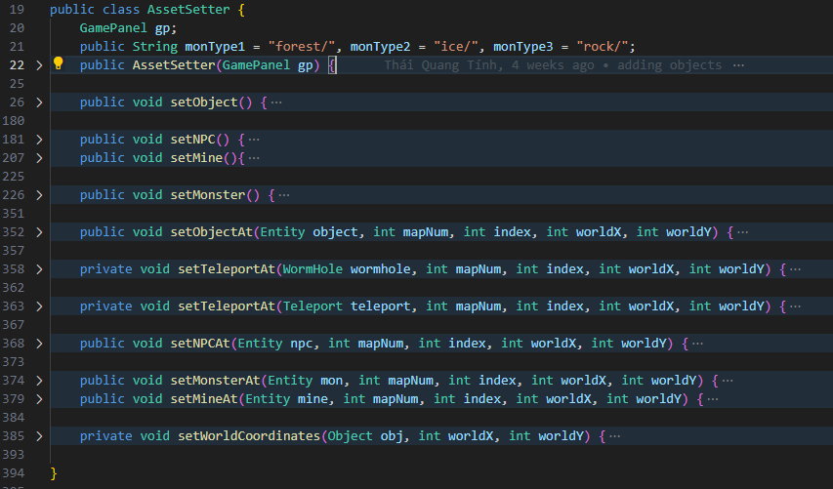

Class Collision Detector:

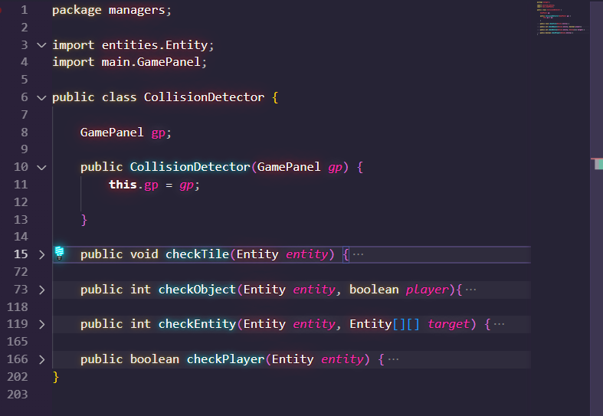

Class Config:

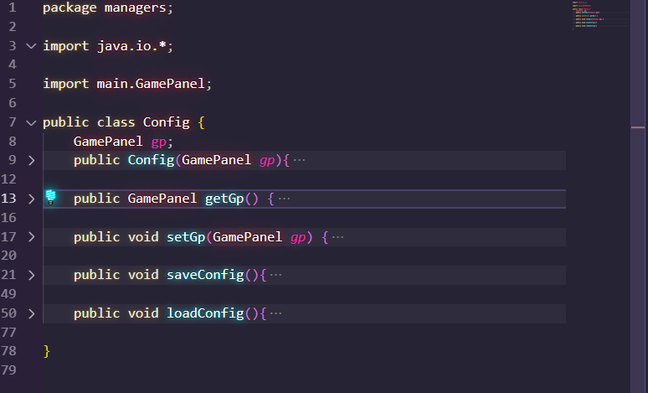

Class Cutscene:

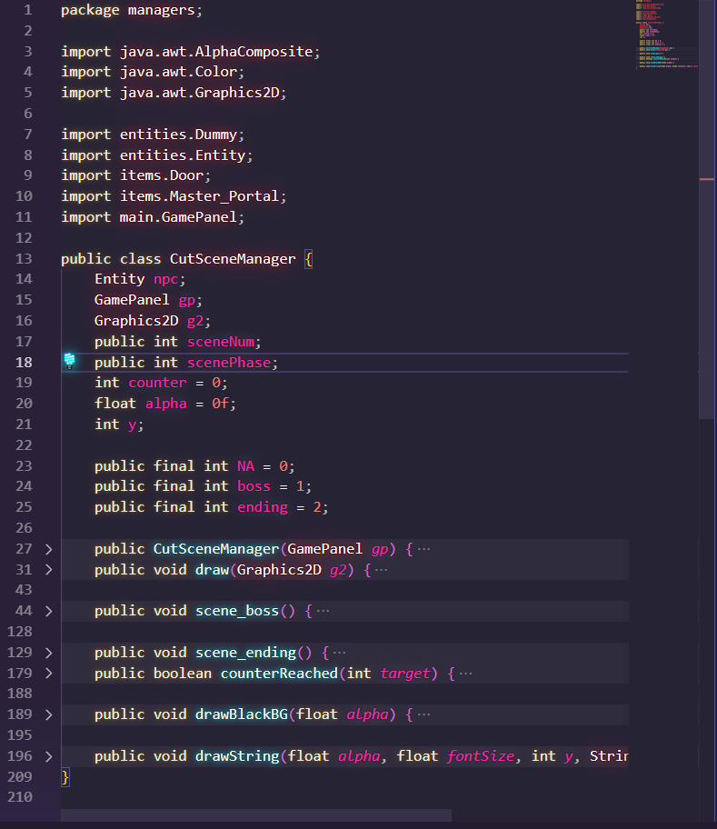

Class Environment:

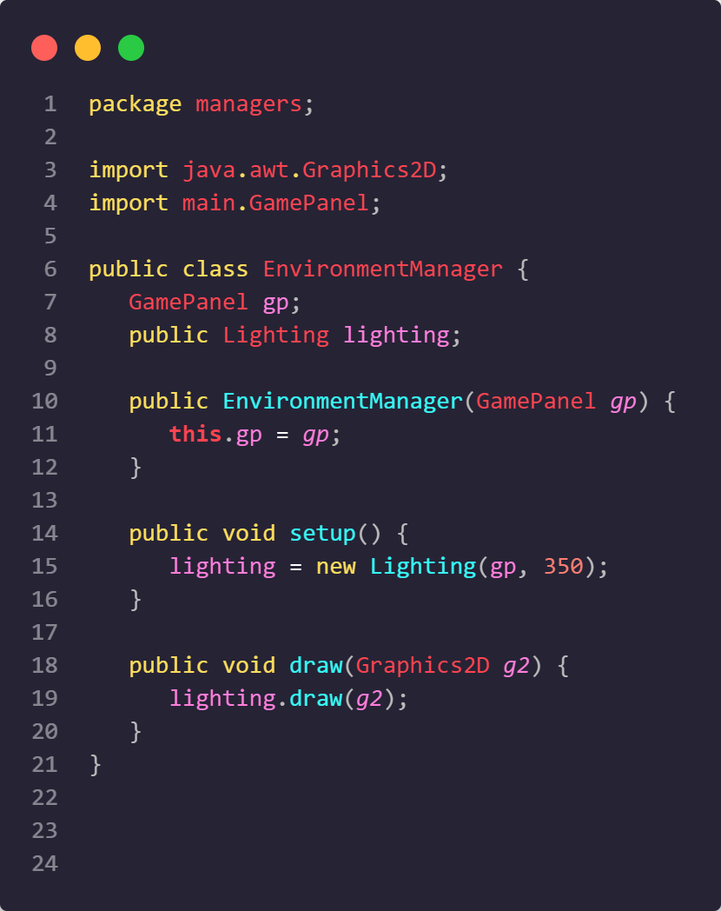

Class Event Handler:

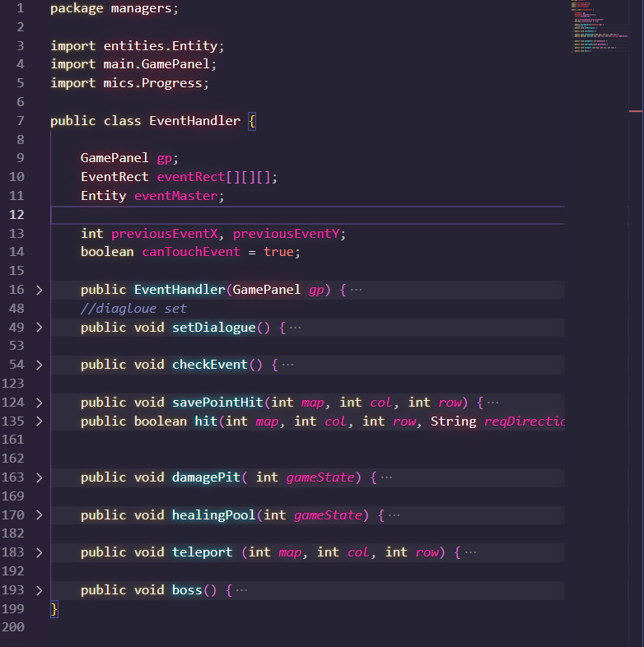

Class Event Rect:

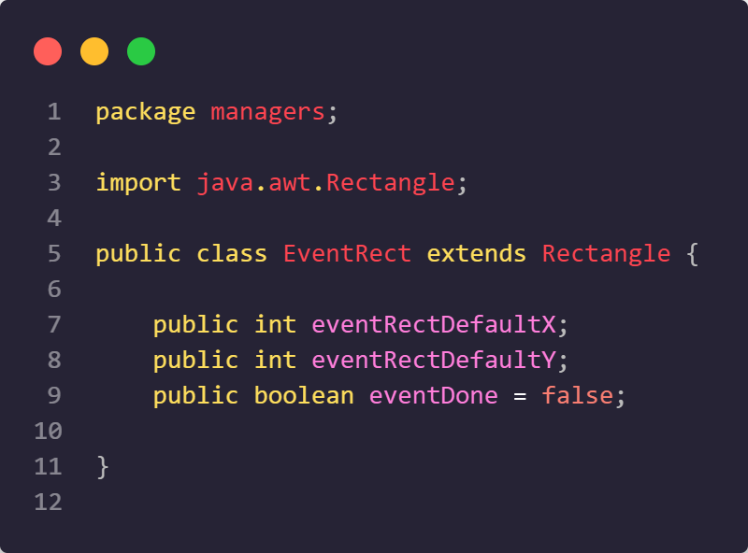

Class KeyHandle:

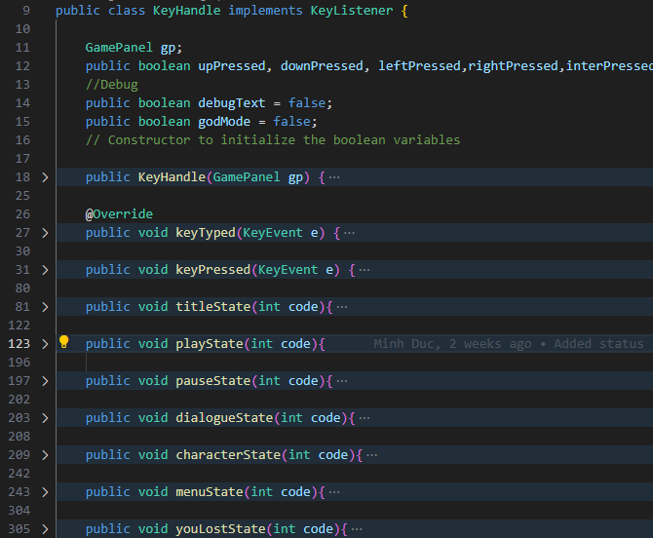

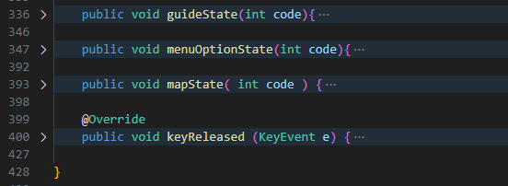

Class Lighting:

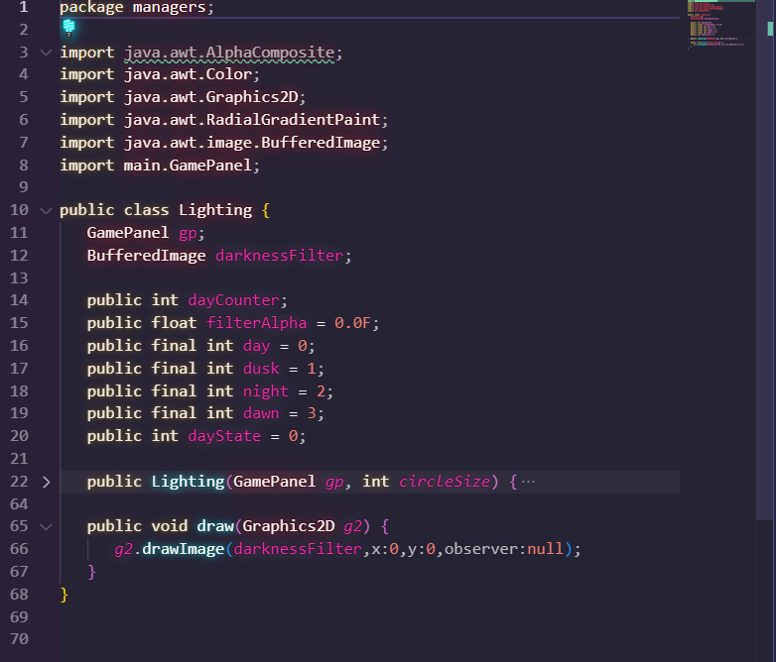

Class Sound:

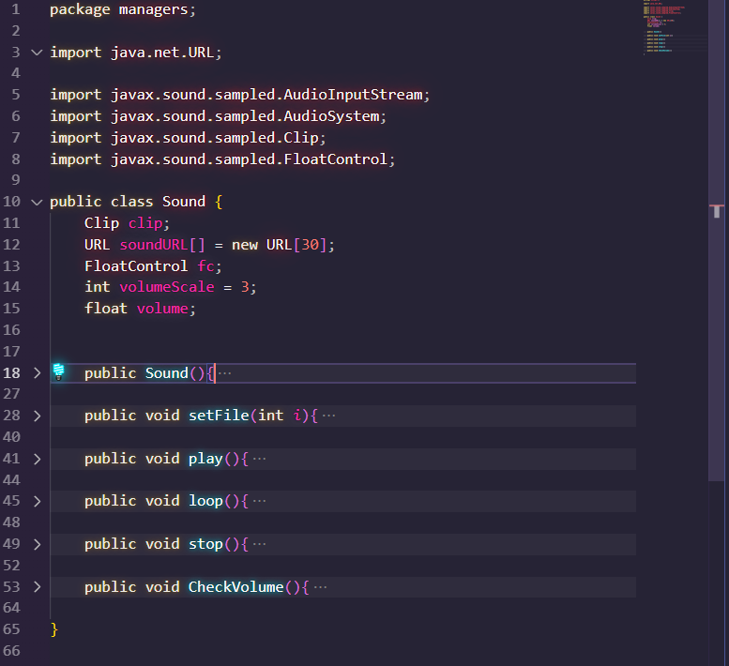

Class UI:

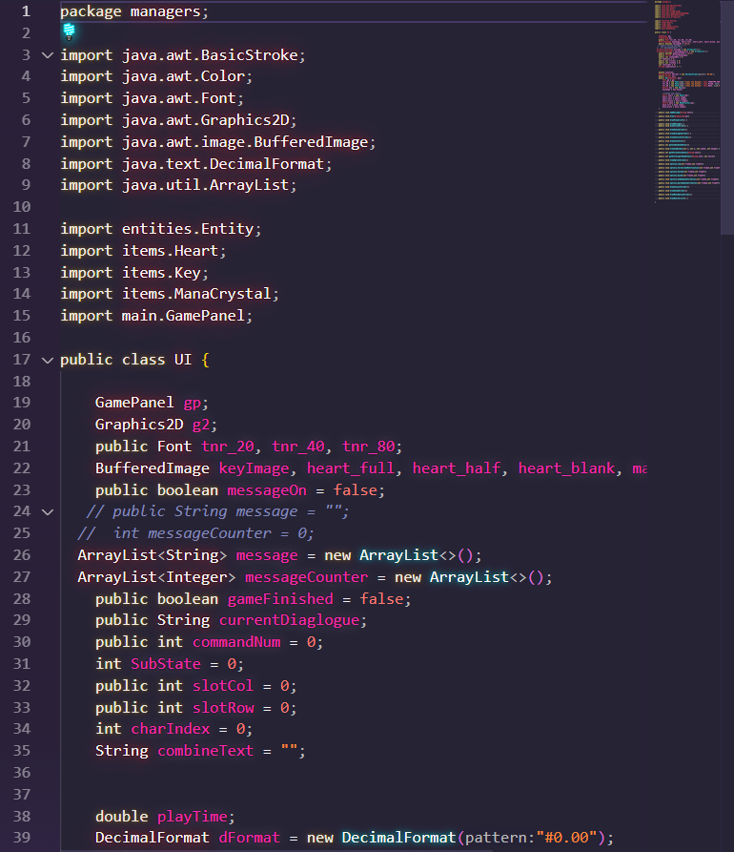

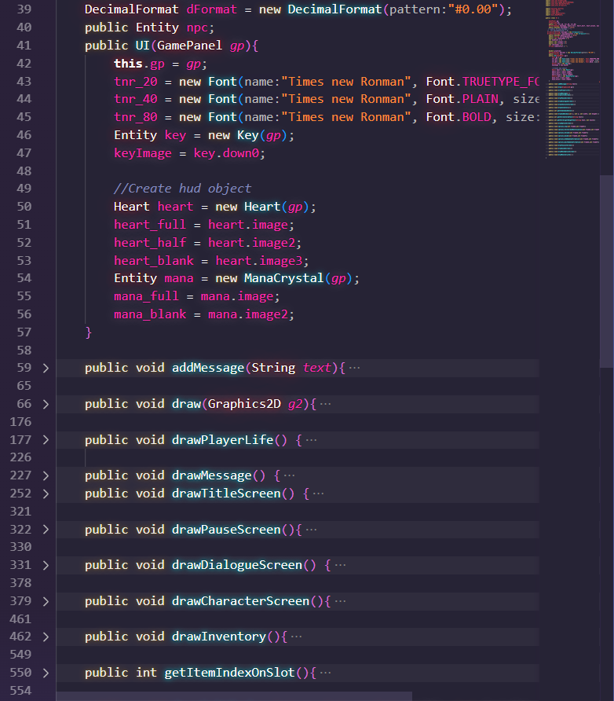

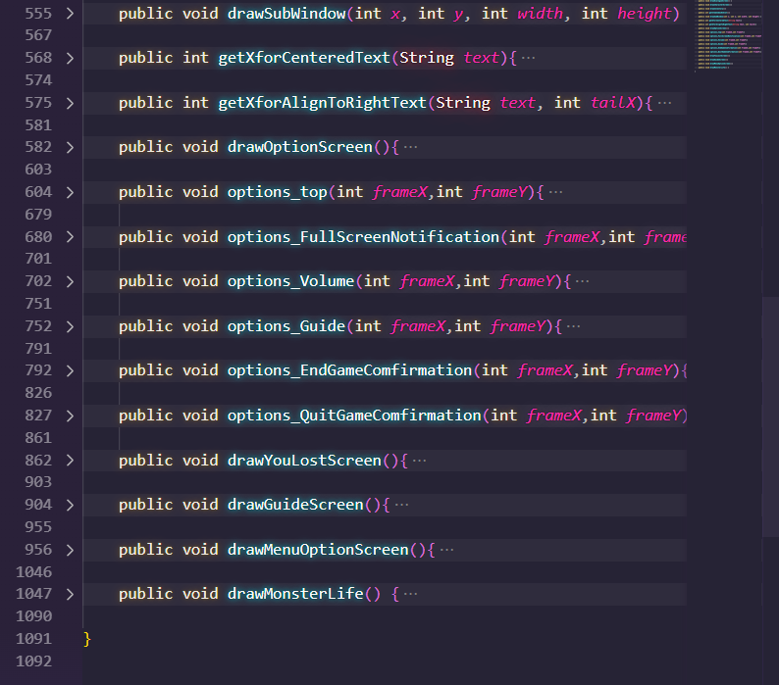

Class UtilityTool:

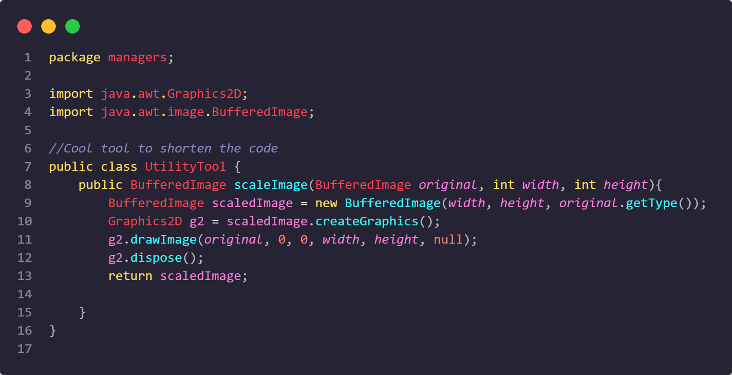

### Map:

Class Map:

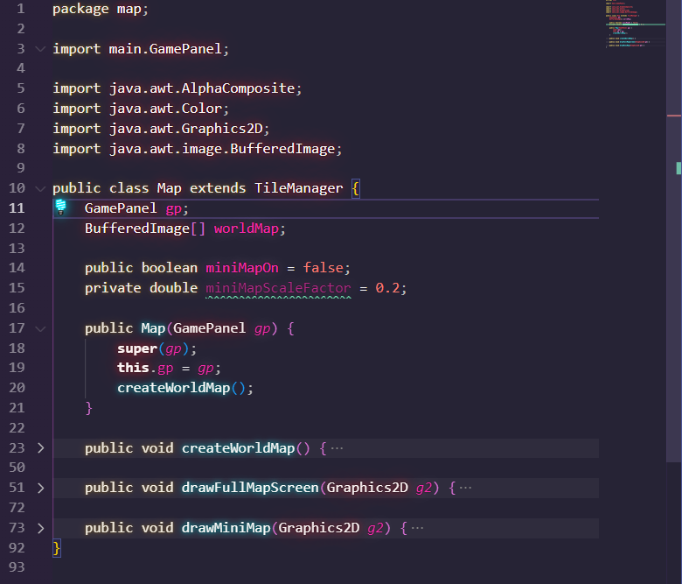

Class Tile:

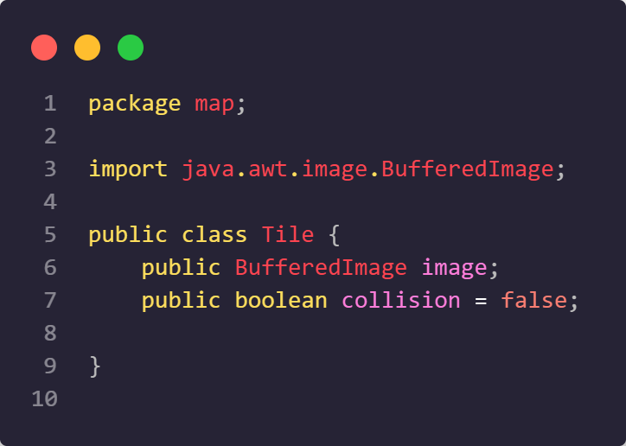

Class Tile Manager:

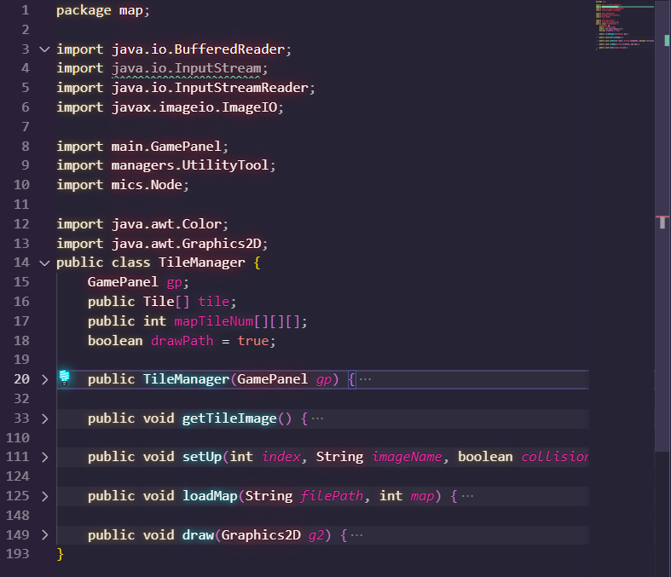

### Mics:

Class Data Storage:

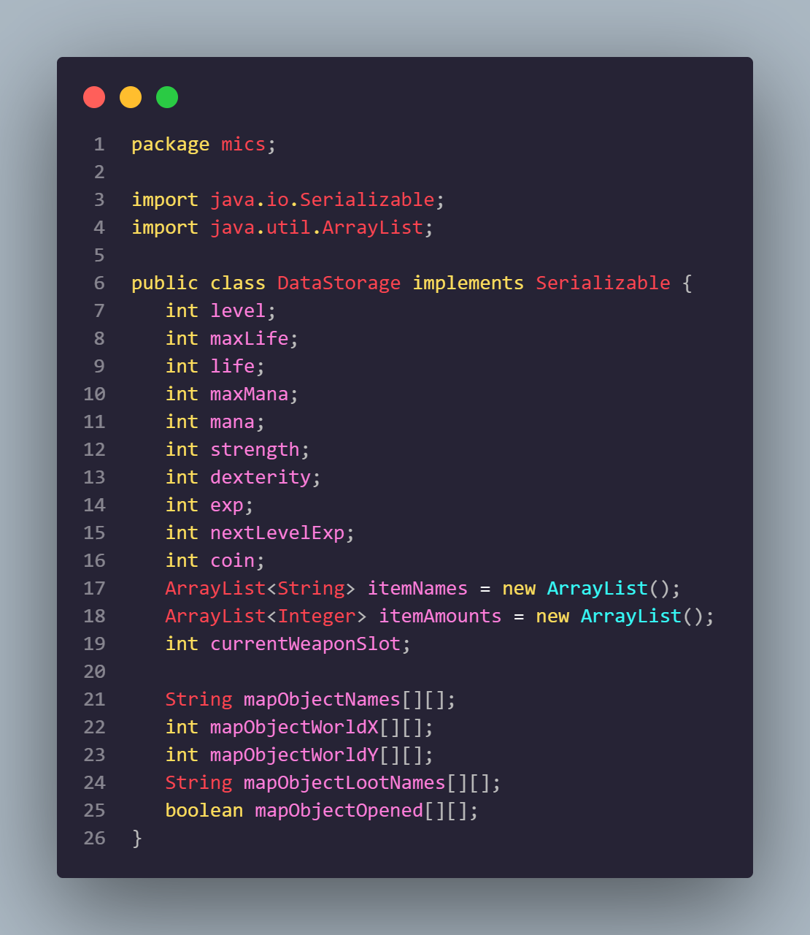

Class Node:

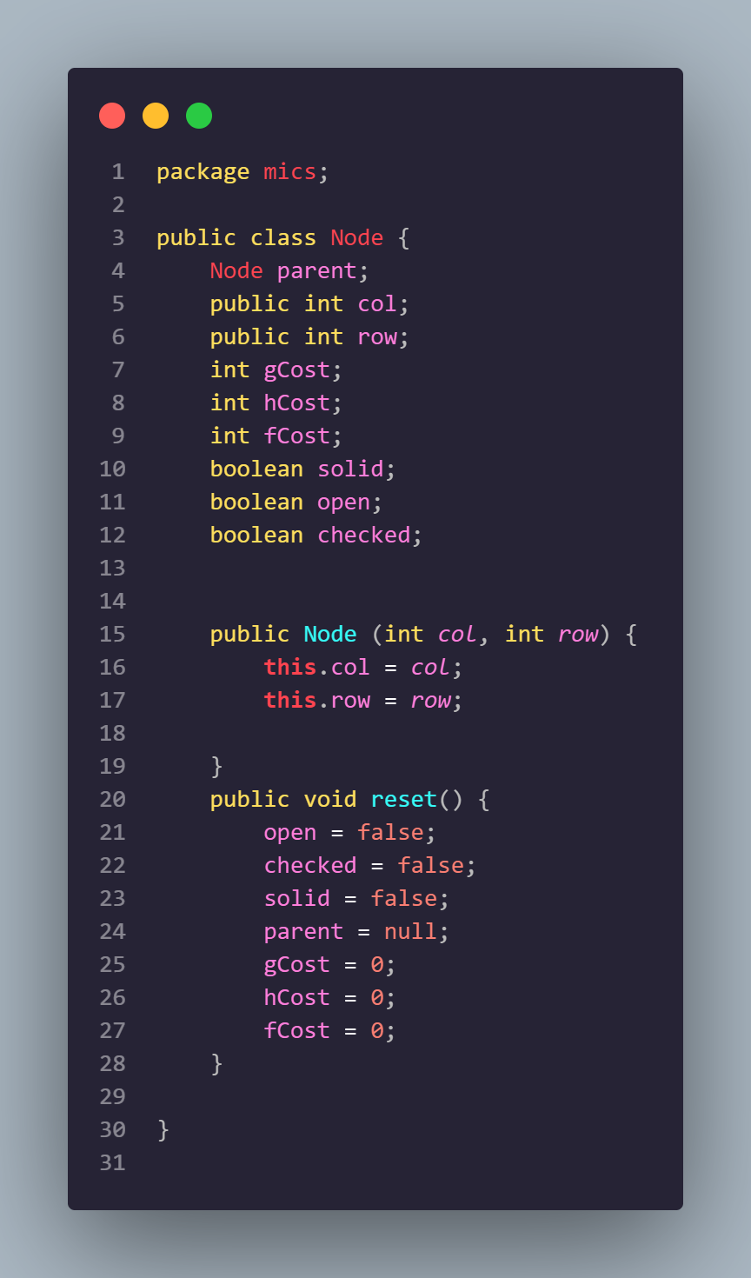

Class Path Finder:

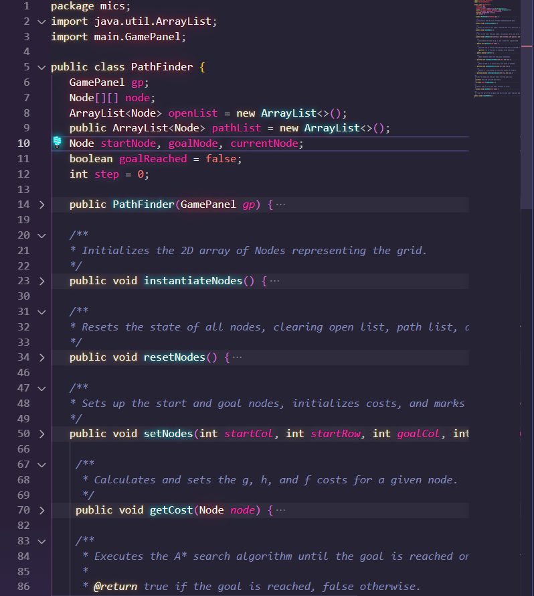

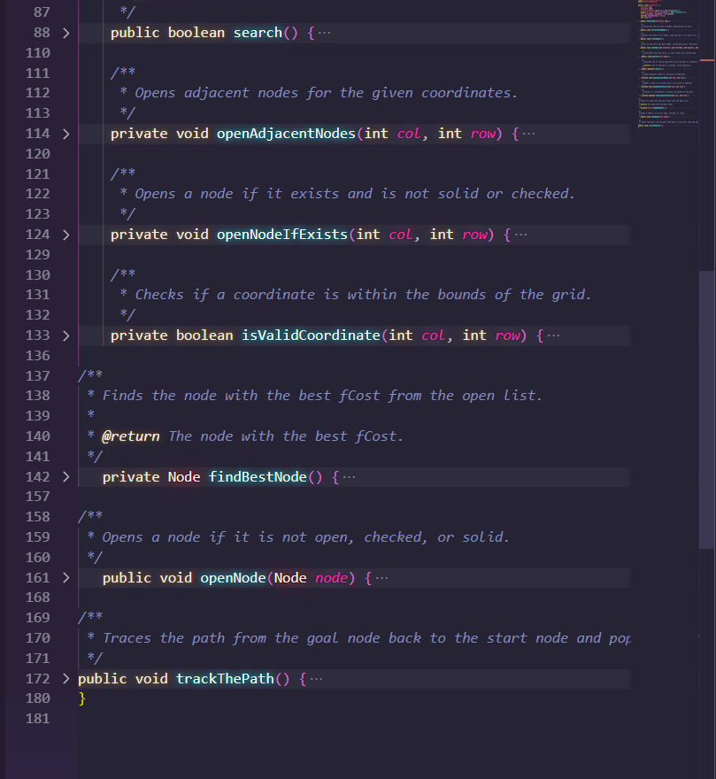

Class Progress:

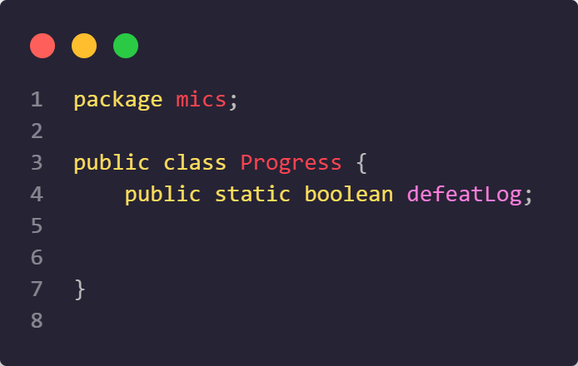

Class Save Load:

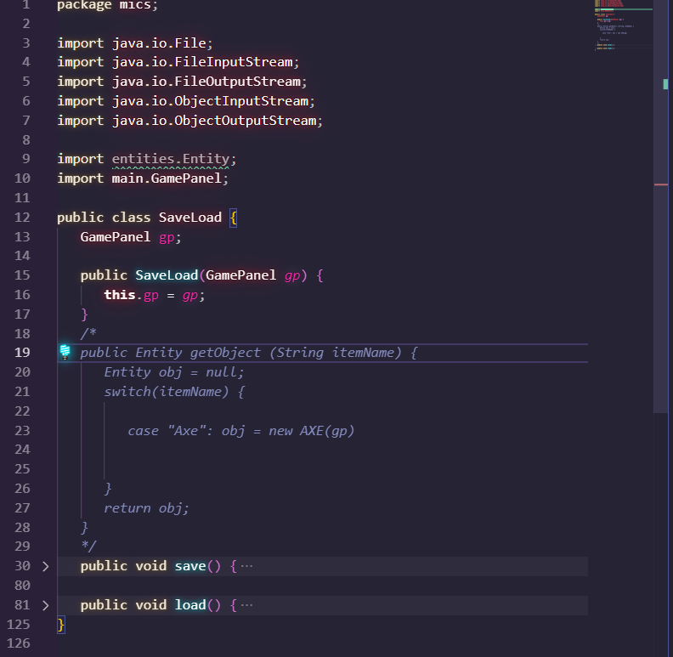

### Res:

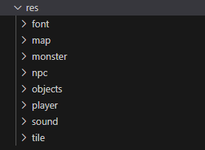

Including data about the game's fonts, images, and sounds.

## 3.4. STORY AND GAMEPLAY

### The meaning of “Ecsigma”

The nomenclature of our project, "Ecsigma," emerges as a deliberate fusion of the words "escape" and "enigma," culminating in a portmanteau that intricately captures the essence of our creative endeavor. The term "escape," denoting the act of liberation from a confined space or circumstance, serves as a foundational element. Its significance extends beyond the physical realm, carrying symbolic connotations of breaking free from limitations and overcoming challenges. Conversely, "enigma," with its connotations of perplexity and intricacy, adds layers of ambiguity and fascination to the amalgamated term. In the context of "Ecsigma," this portmanteau alludes to the enigmatic and mysterious, interwoven with elements of escape. It beckons the audience into a realm that transcends the ordinary, inviting intrigue and wonder.

### About the Story

Our narrative genesis finds inspiration in James Dashner's renowned novel, The Maze Runner, serving as the catalyst for our game's thematic core. Within the intricate tapestry of "Escigma," this nomenclature assumes profound significance, permeating the narrative as a central motif. It epitomizes the protagonists' unwavering determination to escape a labyrinth shrouded in darkness and perils, representing a fervent desire for liberation, knowledge acquisition, and an improved existence.

"Escigma" becomes a symbol of the protagonists' collective will to reclaim autonomy and resist the unseen forces that have thrust them into this confining maze. The journey unfolds as a relentless pursuit to surmount myriad challenges, unravel the truths of their predicament, and navigate the intricate maze towards freedom. The game transcends mere physical escape, delving into the protagonists' exploration of identity, the reasons behind their imprisonment, and a yearning to fathom the world beyond their confines.

In essence, "Escigma" embodies the protagonists' quest for independence, self-awareness, and an optimistic vision for a brighter future. It encapsulates their unwavering pursuit of justice, truth, and a profound sense of inclusion, transforming the game into a narrative odyssey rich with meaning and purpose.

### The gameplay

#### Commencement: The odyssey within "Escigma" commences at the labyrinth's threshold, where players are equipped with a rudimentary map and a weapon to navigate the intricate maze. The labyrinth, a multi-tiered structure, presents distinct challenges at each level.

1. Navigation Mastery: Players adeptly traverse interconnected corridors and chambers, unveiling twists, turns, and hidden passages amid encounters with formidable monsters. The map dynamically updates, chronicling explored areas and highlighting potential pathways.
2. Overcoming Obstacles: Perseverance is tested through encounters with puzzles, riddles, and traps obstructing progress. Puzzles, once unraveled, unlock doors, revealing new labyrinth sections. Vigilance is paramount, with monsters and guardians guarding key areas; keys become essential for circumventing obstacles.
3. Resource Accumulation: Strategic resource collection, including lanterns to illuminate paths, becomes pivotal. Potions offering temporary enhancements in speed, strength, or healing are discovered. Hidden chests yield secret weapons, augmenting the player's arsenal.
4. Treasures and Artifacts: Hidden chambers house treasures and artifacts, some bestowing special abilities or insights crucial for the journey. The ultimate objective lies in attaining the elusive Treasure of Ancients, concealed in the labyrinth's depths.
5. Dynamic Environmental Shifts: The labyrinth's dynamism unfolds as environmental changes are triggered by specific events, reshaping the layout and introducing new challenges. Weather fluctuations, anomalies, and evolving monster dynamics maintain a dynamic gameplay experience.
6. Divergent Endings: Player choices, actions, and acquired treasures intricately shape the game's outcome. "Escigma" offers multiple endings, contingent on the paths chosen and the challenges triumphed over, ensuring a personalized and captivating denouement to each player's unique journey.

## 

## CHAPTER 4: FUTURE PLANS

Looking ahead, our roadmap includes some exciting upgrades to elevate the gaming experience in "Escigma." We're gearing up to introduce new features like a sanity system, adding a psychological twist to the gameplay. Expect expanded horizons with fresh maps, featuring unique monsters and challenging bosses.

In the spirit of unpredictability, an Easter Egg is in the works. Players may stumble upon hidden surprises that could either aid or present unexpected challenges. We're also refining the boss mechanic to empower players with dodge and counter options, injecting more strategy into the encounters.

Simplicity is key, so we're on a mission to enhance code readability through a thoughtful redesign. This not only makes life easier for our developers but also ensures a smoother deployment process.

As we embark on these enhancements, our goal is to keep "Escigma" not just entertaining but also poised for continuous growth, providing a dynamic and enjoyable gaming adventure.

## 

## REFERENCES

1. Karrin Gaming: [Platformer Tutorial - Java](https://youtube.com/playlist?list=PL4rzdwizLaxYmltJQRjq18a9gsSyEQQ-0&si=4UqXjPtfutMHjrcI)
2. RyiSnow: [How to Make a 2D Game in Java](https://youtube.com/playlist?list=PL_QPQmz5C6WUF-pOQDsbsKbaBZqXj4qSq&si=qn28hz-Nlxvd2K8E)
3. Github: [Treasure Hunt Game](https://github.com/LordRekishi/treasure-hunt-game)